System Dynamics Homework #1
2023/02/22
Due: 3/08
程式練習
作業以電子檔繳交，以word撰寫，附上程式碼於每題後面，並作說明。
將以下函數以Python畫出圖形，每一函數均有數量不等之參數，在圖形中同時顯示不同參數值對於函數變化的影響，並由趨勢變化討論各參數的影響. (橫軸與縱軸範圍自訂，需要能呈現該函數之主要特性)

- y(t)=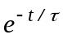

code
from matplotlib import pyplot as plt
import numpy as np

T=1
t = np.arange(-5,5,0.01)
y = np.exp(-t/T)

plt.plot(t, y, 'r')
plt.xlabel("t")
plt.ylabel("y")
plt.title("y = exp(-t/T)")
plt.figtext(0, 0, "T=1")

plt.show()
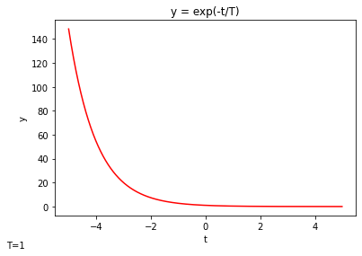
- y(t)=(t/τ)

code
from matplotlib import pyplot as plt
import numpy as np

T=1
t = np.arange(-5,5,0.01)
y = (t/T)*np.exp(-t/T)

plt.plot(t, y, 'r')
plt.xlabel("t")
plt.ylabel("y")
plt.title("y =(t/T)*exp(-t/T)")
plt.figtext(0, 0, "T=1")
plt.show()
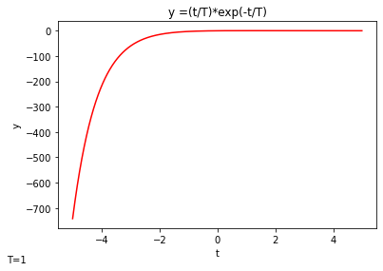
- y(t)=Ae^{-t/2}+Be^{-t/10}

code
from matplotlib import pyplot as plt
import numpy as np

A=1
B=1

t = np.arange(-5,5,0.01)
y = A*np.exp(-t/2)+B*np.exp(-t/10)

plt.plot(t, y, 'r')
plt.xlabel("t")
plt.ylabel("y")
plt.title("y =A*exp(-t/2)+B*exp(-t/10)")
plt.figtext(0, 0, "A=1,B=1")
plt.show()
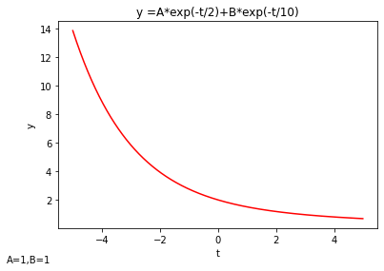

- y(t)=A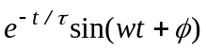, A=1, w=1, φ=0, 45 and 90 degrees.

code
from matplotlib import pyplot as plt
import numpy as np

A=1
w=1
T=1
th1=0
th2=45/180*np.pi
th3=90/180*np.pi

t = np.arange(-5,5,0.01)
y1 = A*np.exp(-t/T)*np.sin(w*t+th1)
y2 = A*np.exp(-t/T)*np.sin(w*t+th2)
y3 = A*np.exp(-t/T)*np.sin(w*t+th3)

plt.plot(t, y1,label='Angle=0')
plt.plot(t,y2,label='Angle=pi/4')
plt.plot(t,y3,label='Angle=pi/2')
plt.xlabel("t")
plt.ylabel("y")
plt.title("y = A*exp(-t/T)*sin(w*t+th)")
plt.legend(loc='best')
plt.figtext(0, 0, "A=1,W=1,T=1")
plt.show()

